F.Y. BCA – SEMESTER I
EXPLORATORY DATA ANALYSIS
WINE QUALITY ANALYSIS
Project Group No. 3
Dataset: UCI Wine Quality Dataset

Submitted as part of the F.Y. BCA Semester I EDA Project

1. Introduction & Objective
Wine Quality Analysis is an Exploratory Data Analysis (EDA) project based on the UCI Wine Quality dataset. In this project, we study different properties of wine and see how they are related to the quality score.
The main aim is to understand the data in a simple way by using statistics, tables and graphs. Python is used to clean, calculate and show the results.

Objectives
- To understand the Wine Quality dataset.
- To identify the variables and their data types.
- To check missing values and duplicate records.
- To calculate basic statistics such as mean, median, standard deviation, minimum and maximum.
- To study one variable at a time and compare two variables.
- To group the data according to quality scores.
- To find relationships between variables using correlation.
- To make graphs that make the results easy to understand.
- To find the main points from the analysis.

2. Dataset Description
The dataset is taken from the UCI Machine Learning Repository. It contains information about red and white wine samples. The data has measurements such as acidity, sugar, chlorides, sulphates and alcohol, along with a quality score.
Dataset | Records | Quality score
Red Wine | 1,599 | 3 to 8
White Wine | 4,898 | 3 to 9
The target variable is Quality. The dataset is useful because we can compare the physical and chemical properties of wine with its quality.

3. Data Types and Variables
No. | Variable | Simple meaning | Type
1 | Fixed Acidity | Amount of fixed acids | Numerical
2 | Volatile Acidity | Amount of volatile acids | Numerical
3 | Citric Acid | Amount of citric acid | Numerical
4 | Residual Sugar | Sugar left after fermentation | Numerical
5 | Chlorides | Amount of chlorides | Numerical
6 | Free Sulfur Dioxide | Free sulphur dioxide | Numerical
7 | Total Sulfur Dioxide | Total sulphur dioxide | Numerical
8 | Density | Density of wine | Numerical
9 | pH | Acidic/basic level | Numerical
10 | Sulphates | Amount of sulphates | Numerical
11 | Alcohol | Alcohol content | Numerical
12 | Quality | Quality rating of wine | Numerical

4. Tools Used for Analysis
Tool | Use
Python | Main language used for analysis
Pandas | Reading and working with the data
NumPy | Numerical calculations
Matplotlib | Making graphs
Seaborn | Making statistical graphs and heatmaps
Google Colab | Writing and running Python code
UCI Repository | Source of the dataset

5. Data Quality Assessment
Before starting the analysis, the data was checked to make sure it was suitable for use.
Check | Result | Simple explanation
Missing values | No missing values | All required values are present.
Duplicate records | Red: 240; White: 937 | Some rows are repeated in the datasets.
Data type | Numerical | The main variables contain numerical values.
Overall quality | Suitable for analysis | The dataset can be used for EDA.

6. Descriptive Statistics
Descriptive statistics help us understand the data using a few important numbers. Mean means average, median is the middle value, standard deviation shows how spread out the values are, and minimum and maximum show the lowest and highest values.

6.1 Red Wine
Variable | Mean | Median | Std. Dev. | Min | Max
Fixed Acidity | 8.32 | 7.9 | 1.74 | 4.6 | 15.9
Volatile Acidity | 0.53 | 0.52 | 0.18 | 0.12 | 1.58
Citric Acid | 0.27 | 0.26 | 0.19 | 0 | 1
Residual Sugar | 2.54 | 2.2 | 1.41 | 0.9 | 15.5
Chlorides | 0.09 | 0.08 | 0.05 | 0.01 | 0.61
Free Sulfur Dioxide | 15.87 | 14 | 10.46 | 1 | 72
Total Sulfur Dioxide | 46.47 | 38 | 32.9 | 6 | 289
Density | 1 | 1 | 0 | 0.99 | 1
pH | 3.31 | 3.31 | 0.15 | 2.74 | 4.01
Sulphates | 0.66 | 0.62 | 0.17 | 0.33 | 2
Alcohol | 10.42 | 10.2 | 1.07 | 8.4 | 14.9
Quality | 5.64 | 6 | 0.81 | 3 | 8

6.2 White Wine
Variable | Mean | Median | Std. Dev. | Min | Max
Fixed Acidity | 6.85 | 6.8 | 0.84 | 3.8 | 14.2
Volatile Acidity | 0.28 | 0.26 | 0.1 | 0.08 | 1.1
Citric Acid | 0.33 | 0.32 | 0.12 | 0 | 1.66
Residual Sugar | 6.39 | 5.2 | 5.07 | 0.6 | 65.8
Chlorides | 0.05 | 0.04 | 0.02 | 0.01 | 0.35
Free Sulfur Dioxide | 35.31 | 34 | 17.01 | 2 | 289
Total Sulfur Dioxide | 138.36 | 134 | 42.5 | 9 | 440
Density | 0.99 | 0.99 | 0 | 0.99 | 1.04
pH | 3.19 | 3.18 | 0.15 | 2.72 | 3.82
Sulphates | 0.49 | 0.47 | 0.11 | 0.22 | 1.08
Alcohol | 10.51 | 10.4 | 1.23 | 8 | 14.2
Quality | 5.88 | 6 | 0.89 | 3 | 9
From the table, white wine has much higher average residual sugar than red wine. The average quality is 5.64 for red wine and 5.88 for white wine.

7. Univariate Analysis
Univariate analysis means studying one variable at a time. It helps us see which values occur more often and how the data is spread.
Quality | Red Wine | White Wine
3 | 10 | 20
4 | 53 | 163
5 | 681 | 1457
6 | 638 | 2198
7 | 199 | 880
8 | 18 | 175
9 | — | 5
Quality 5 and 6 are the most common scores. Very low and very high quality scores are seen less often.
Histograms can be used for variables such as alcohol and pH. Box plots can also help us see the spread and possible unusual values.

8. Bivariate Analysis
Bivariate analysis means studying two variables together. Here, we compare some wine properties with the quality score.
Variables compared | Graph used | What we can see
Alcohol and Quality | Scatter plot | Whether higher alcohol is linked with higher quality
Volatile Acidity and Quality | Scatter plot | Whether acidity changes with quality
Residual Sugar and Quality | Scatter plot | Whether sugar is related to quality
Fixed Acidity and Quality | Scatter plot | Whether fixed acidity changes with quality

9. Grouping and Aggregation
Here, wine samples are grouped by their quality score and average values are calculated. This makes comparison easier.

9.1 Red Wine
Quality | Avg. Alcohol | Avg. Volatile Acidity | Avg. Residual Sugar
3 | 9.96 | 0.88 | 2.64
4 | 10.27 | 0.69 | 2.69
5 | 9.9 | 0.58 | 2.53
6 | 10.63 | 0.5 | 2.48
7 | 11.47 | 0.4 | 2.72
8 | 12.09 | 0.42 | 2.58

9.2 White Wine
Quality | Avg. Alcohol | Avg. Volatile Acidity | Avg. Residual Sugar
3 | 10.34 | 0.33 | 6.39
4 | 10.15 | 0.38 | 4.63
5 | 9.81 | 0.3 | 7.33
6 | 10.58 | 0.26 | 6.44
7 | 11.37 | 0.26 | 5.19
8 | 11.64 | 0.28 | 5.67
9 | 12.18 | 0.3 | 4.12
The average alcohol level generally becomes higher for higher quality scores. In red wine, volatile acidity generally becomes lower as quality increases.

10. Correlation Analysis
Correlation tells us whether two numerical variables move together. A positive value means they tend to increase together, while a negative value means one tends to decrease when the other increases. Correlation does not prove that one variable causes the other.
Variable | Red Wine | White Wine
Alcohol | 0.476 | 0.436
Volatile Acidity | -0.391 | -0.195
Sulphates | 0.251 | 0.054
Citric Acid | 0.226 | -0.009
Density | -0.175 | -0.307
Total Sulfur Dioxide | -0.185 | -0.175
Chlorides | -0.129 | -0.21
Residual Sugar | 0.014 | -0.098
Alcohol has a positive relationship with quality in both datasets. Volatile acidity has a negative relationship, especially in red wine. Density also has a negative relationship.

11. Visualization
Graphs make the results easier to understand. The following graphs are suitable for this project:
- Red Wine Quality Distribution – Bar Chart
- White Wine Quality Distribution – Bar Chart
- Alcohol Distribution – Histogram
- pH Distribution – Histogram
- Alcohol vs Quality – Scatter Plot
- Volatile Acidity vs Quality – Scatter Plot
- Correlation Heatmap
These graphs help us see the distribution of quality scores, the spread of alcohol and pH, relationships with quality, and the correlation between numerical variables.
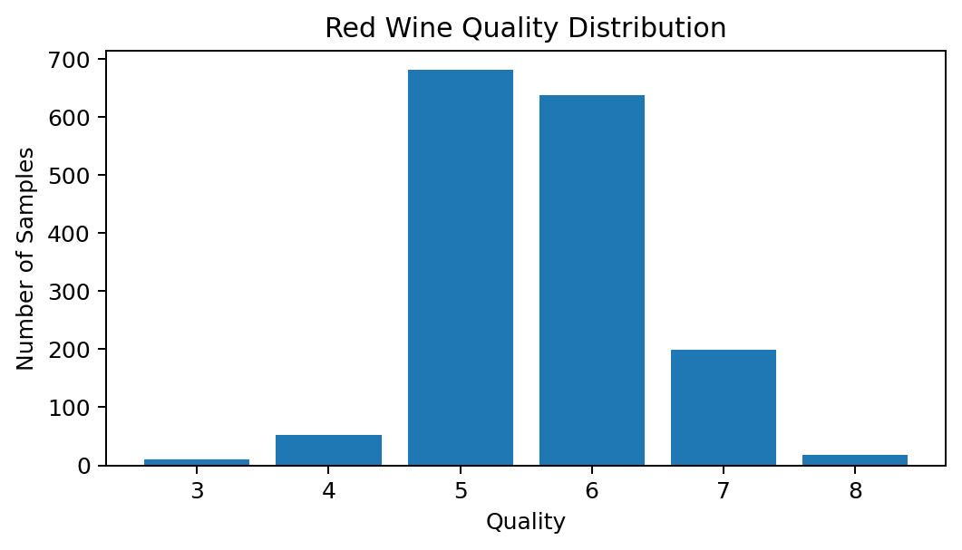
Graph created from the values in the project dataset.
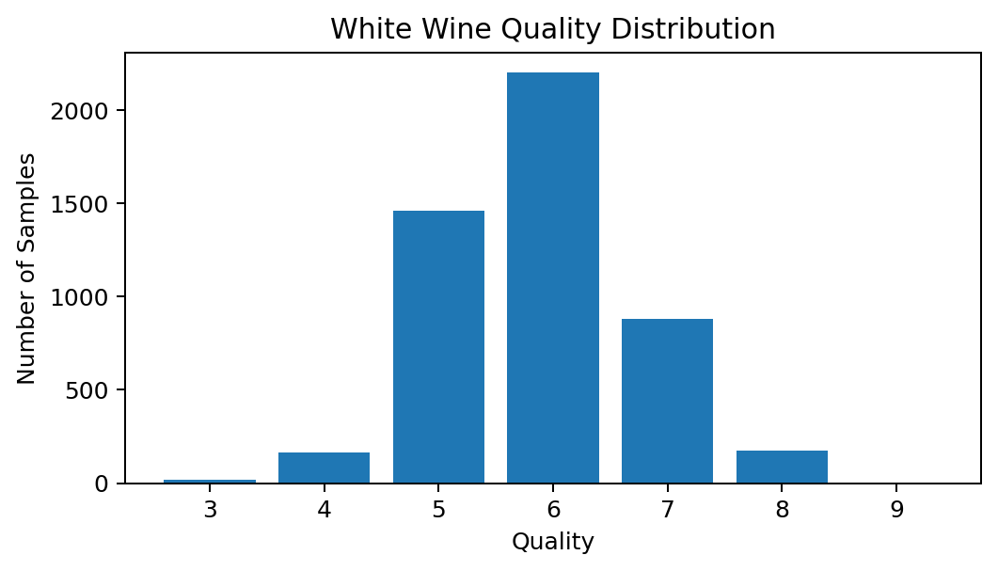
Graph created from the values in the project dataset.
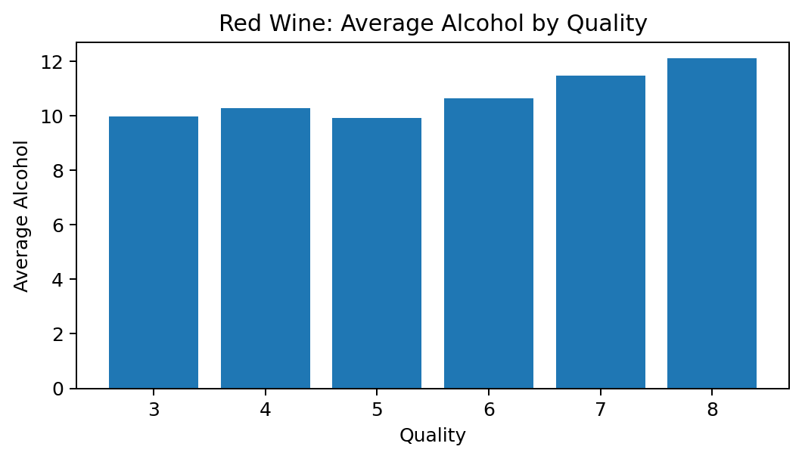
Graph created from the values in the project dataset.
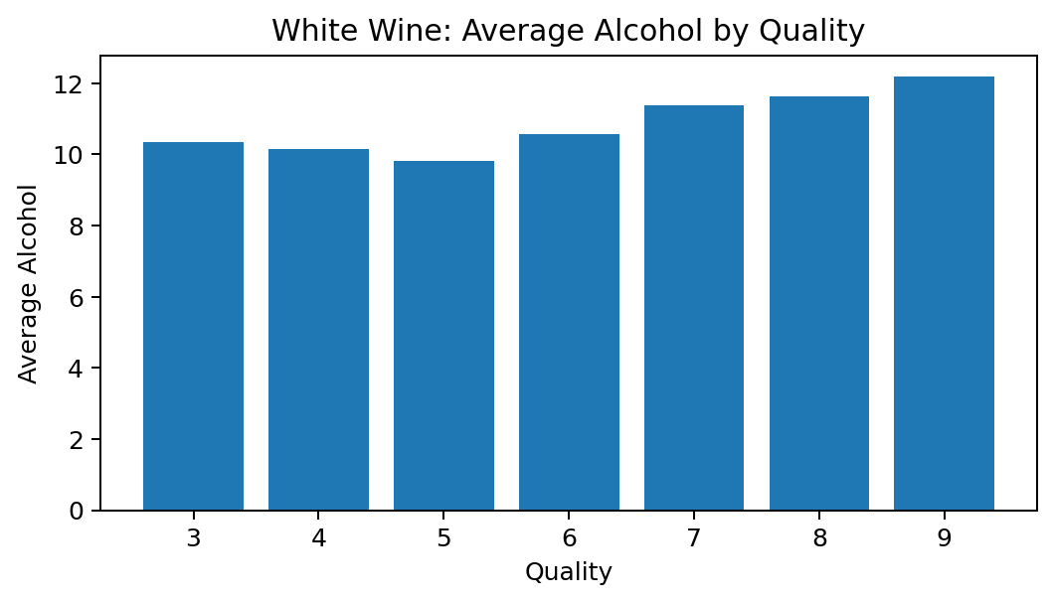
Graph created from the values in the project dataset.

12. Key Findings
- The red wine dataset has 1,599 records and the white wine dataset has 4,898 records.
- No missing values were found.
- Duplicate records are present: 240 in red wine and 937 in white wine.
- Quality 5 and 6 are the most common scores.
- Average quality is 5.64 for red wine and 5.88 for white wine.
- White wine has higher average residual sugar.
- Alcohol has a positive correlation with quality in both datasets.
- Volatile acidity has a negative correlation with quality, especially in red wine.
- Density also has a negative correlation with quality.
- Average alcohol generally increases at higher quality levels.
- Graphs make the patterns easier to understand.

13. Conclusion
In this project, we studied the Wine Quality dataset using Exploratory Data Analysis. We checked the data, calculated basic statistics, studied individual variables, compared variables, grouped the data and checked correlations.
The analysis shows that quality scores 5 and 6 are the most common. Alcohol has a positive relationship with quality, while volatile acidity has a negative relationship, especially in red wine. The graphs also make these patterns easier to see.
Overall, this project helped us understand how Python and its libraries can be used to study real data in a simple and useful way.

14. References
- UCI Machine Learning Repository – Wine Quality Dataset, Dataset ID 186.
- UCI Machine Learning Repository – Wine Quality Dataset documentation.
- Python Documentation.
- Pandas Documentation.
- NumPy Documentation.
- Matplotlib Documentation.
- Seaborn Documentation.
Dataset source: https://archive.ics.uci.edu/dataset/186/wine+quality

15. Code (GitHub)
The Python code used for the project includes dataset loading, data checking, descriptive statistics, univariate analysis, bivariate analysis, grouping, correlation analysis and visualization.
GitHub Repository: To be added

